Example
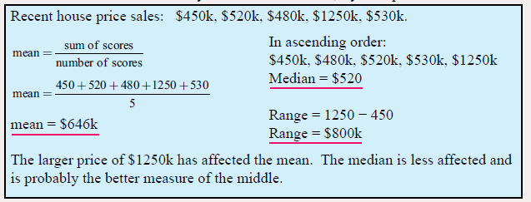

Questions.
Mean = Median = Range =

Is there a large difference between the Mean and the Median?
Why do you think that is?

Mean = Median = Range =

Is there a large difference between the Mean and the Median?
Why do you think that is?

Mean = Median = Range =

Is there a large difference between the Mean and the Median?
Why do you think that is?

